Name: Kashif Raza
Course: Python With Ai
Teacher Name: Miss Qirrat
ASSIGNMENT #2
Practice Question 1:
Code:

sum=0
while True:
a=int(input("enter a num: "))
if a<0:
break
if a>0:
sum+=a
print("sum of positive numbers", sum)
Output:
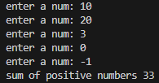

Practice Question 2:
Code:
num = 1
while num <= 50:
if num % 3 == 0 and num % 5 == 0:
print(num)
num += 1
OUTPUT
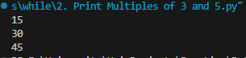

Practice Question 3:
Code:
num = int(input("Enter a positive integer: "))
count = 0
while num > 0:
digit = num % 10
if digit % 2 == 0:
count += 1
num = num // 10
print("Number of even digits:", count)

OUTPUT:
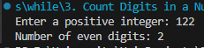

Practice Question 4:
Code:
num = int(input("Enter a number: "))
reverse = 0
while num > 0:
digit = num % 10 # last digit hai ye
if digit % 2 != 0: # check kro digit odd hai ya nh
reverse = reverse * 10 + digit
num = num // 10 # remove kro last digit ko
print("Reversed odd digits:", reverse)

OUTPUT:
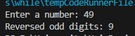

Practice Question 5:
Code:
largest = None

while True:
num = int(input("Enter a number (0 to stop): "))
if num == 0:
break # stop kro jab 0 enter ho
if largest is None or num > largest:
largest = num
if largest is not None:
print("Largest number entered:", largest)
else:
print("No numbers were entered.")

OUTPUT:
